Exercise (Instructions): Event & Binding with ngModel

Objectives and Outcomes

In this exercise you will get familiar with Event & Binding using ngModel.

At the end of this exercise you will be able to:

* Create and bind data with an event

Create a new Project

* At a convenient location on your computer, open cmd, create a new project.

Ng new EventBinding

* Create a button Click, and then add an event **(*click)=clicked()***. This will trigger event click and call the function clicked() in return.

import { Component } from '@angular/core';

@Component({

  selector: 'app-root',

  template: `

    <button (click)=clicked()>Click</button>

  `,

  styleUrls: ['./app.component.css']

})

export class AppComponent {

  clicked(){

    console.log('The button is clicked!')

  }

}

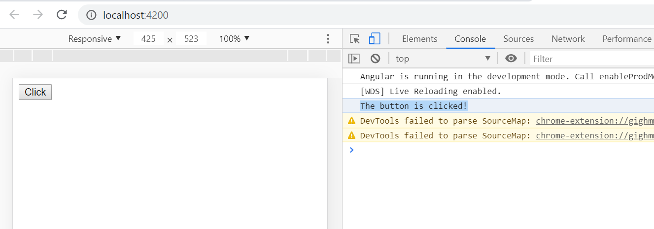

Next, add an <input> tag and add event (keyup.enter)=showText($event), pass the $event to the showText() function

import { Component } from '@angular/core';

@Component({

  selector: 'app-root',

  template: `

    <button (click)=clicked()>Click</button>

    <input type="text" (keyup.enter)=showText($event) />

  `,

  styleUrls: ['./app.component.css']

})

export class AppComponent {

  clicked(){

    console.log('The button is clicked!');

  }

  showText($event){

    console.log($event.target.value);

  }

}

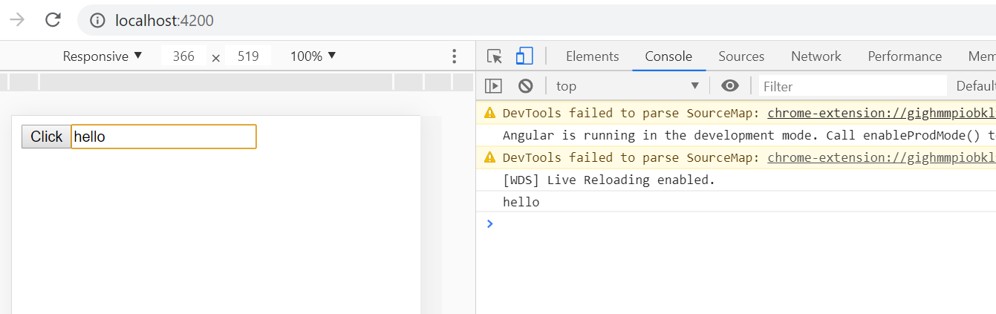

Next, 2 ways databinding:

Add the following to the App.component.ts

import { Component } from '@angular/core';

@Component({

  selector: 'app-root',

  template: `

    <button (click)=clicked()>Click</button>

    <input type="text" [(ngModel)]="mytext" name="text" (keyup.enter)=showText($event) />

    <h1>{{mytext}}</h1>

    `,

  styleUrls: ['./app.component.css']

})

export class AppComponent {

  mytext:string;

  clicked(){

    console.log('The button is clicked!');

  }

  showText($event){

    //console.log($event.target.value);

    console.log(this.mytext);

  }

}

To bind ngModel, you need to import FormsModule. In the file app.module.ts, add 2 lines

import { BrowserModule } from '@angular/platform-browser';

import { NgModule } from '@angular/core';

import {FormsModule} from '@angular/forms';

import { AppComponent } from './app.component';

@NgModule({

  declarations: [

    AppComponent

  ],

  imports: [

    BrowserModule,FormsModule

  ],

  providers: [],

  bootstrap: [AppComponent]

})

export class AppModule { }

Run the app.

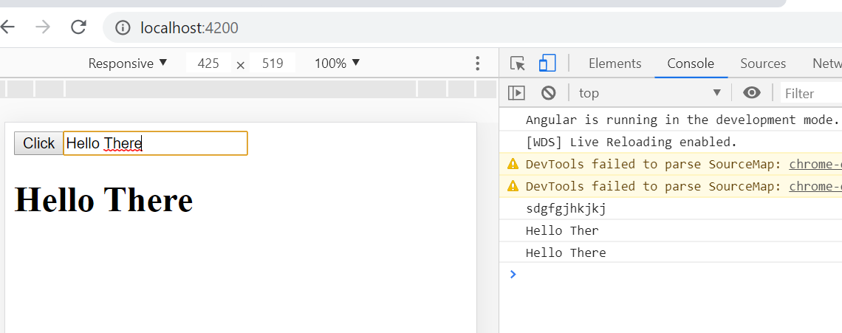

Conclusions